Hussein A. Hegazy
Geology Dept., Fac. Sci., Assiut Uni., 71516 Assiut, Egypt

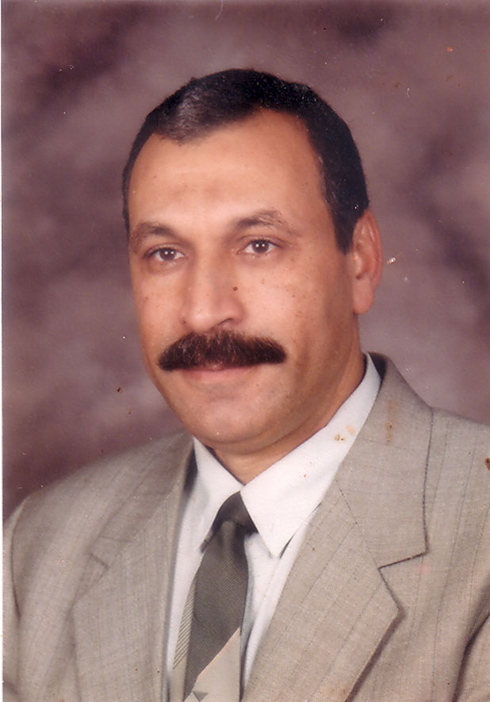
Curriculum Vitae (C.V.)
Prof. Hussein Aziz Mohamed Hegazy
Geology Department, Faculty of Science,
Assiut University, Assiut, 71516, Egypt
E-mail: hhegazy4451@yahoo.com

Personal Data:-
- Name: Hussein Aziz Mohamed Hegazy.
- Nationality: Egyptian.
- Date and place of birth: April. 4,1951, Sohage, Egypt.
- Marital status: Married.
- Mailing address: Geology Department, Faculty of Sciences, Assiut University.
Assiut 71516 Egypt.
- E-mail: hhegazy4451@yahoo.com
- Tel.: +2 088- 2321015 (home)
+2 088-2412227 (work)
+201227831604 (mobile)
- Fax: +2 088-2342708.

Qualifications:-

Ph.D. degree in Geology and geochemistry , Assiut University, Egypt, (Marth,1985).
M.Sc. degree in Geology and mineralogy , Assiut University, Egypt, (May,1980).
B.Sc. General Geology, Assiut University, Egypt, (June,1973).

Academic appointment:

Currently is a professor , in Geology Department, Assiut University, Egypt. from June 2002 till now:
August 1998-June 2002: Associated Professor in Geology Department, Assiut University, Egypt.
October 1992-August 1998: Associated Professor in Earth Science Department. Sebha University. Libya.
December 1991 -September 1992: Associated Professor in Geology Department,
Assiut University, Egypt.
April 1985 – November 1991: Lecturer in Geology Department, Assiut University,
Egypt.
June 1980 - March 1985: Assistant Lecturer in Geology Department, Assiut University, Egypt.
Feb. 1975- May 1980: Demonstrator in Geology Department, Assiut
University, Egypt.

Scholarships and fellowships:
- April to August, 1988- scientific channel system, geology department, University of Glasgow, England.
2- June to August, 1992 scientific channel system Earth Science department , University of Purdue. USA.

External International conferences and workshops:
13-18 July 1992, water rock interaction- WRI – 7/Park City, Utah, USA
1-5 July, 2000 on the African Geology, Graz – Austria
18-24 May 2003, 39th forum on the geology of Industrial minerals. Reno/ Sparks, Nevada, USA
22-30 May, 2005 , 41st forum on geology of Industrial minerals. Istanbul ,Turkey.
9-14 May, 2009 –XXVI Geochemistry of alkaline magmatic rocks , Moscow, USSR
9-16 September , 2011- XXVIII Geochemistry of alkaline magmatic rocks, Belarussia . USSR
14-22 September XXIX- ore potential of alkaline, kimberlite and carbonatite magmatism. Sudak- Moscow, Ukraine – Russian.
29 September – 2 October – 2014 : 30th ore potential of alkaline, kimberlite and carbonatite magmatism, Antalya, Turkey.

Internal International conferences and Meeting:
1-2 March 1989 – 1st International geochemistry conference, fac. Sci. Alexandria Uni. Egypt.
11-15 November 1989 Annual meeting of Egyptian Geology Society, Cairo, Egypt.
10-14 November 1990 - Annual meeting of Egyptian Geology Society, Cairo, Egypt.
6-7 March 1991 – Second international geochemistry conference, fac. Sci. Alexandria Uni. Egypt.
18-23 Jannuary 1992 Geology Arab world conference – Cairo Uni. Egypt.
15-16 September 1999 4th international geochemistry conference, fac. Sci. Alexandria Uni. Egypt.
23-25 November 1999- 1st international conference on the geochemistry on Africa , fac. Sci. Assiut Uni. Egypt.
12-13 September 2001 Five international geochemistry conference, fac. Sci. Alexandria Uni. Egypt.
20-21, January 2003 Five international conference on the Geology of middle east Ain Shams Uni. Egypt.
7-9 December 2003 third international conference on African Geology - fac. Sci. Assiut Uni. Egypt.
8-12 February 2004 five international conference on climate fac. Sci. Assiut Uni. Egypt.
16-19 February 2004 seven ^{th} geology of Arab world conference (GAW), Cairo Uni. Egypt.
16-19 May 2005 second international petroleum conference Cairo – Egypt.
13-16 February 2006 eight^{th} geology of Arab world conference (GAW), Cairo Uni. Egypt.
6-8 March 2007 ten ^{th} international of missing engineering and metallogy - fac. Eng. Assiut Uni. Egypt.
19- 23 March 2007 second international conference of theyths , Cairo Uni. Egypt.
23-24 October 2007 Five international conference on geology of Africa, Assiut Uni. Egypt.
24-27 March 2008 nine ^{th} conference on the of Arab world, (GAW), Cairo Uni. Egypt.
18-20 November 2008 forth international conference of theyths – Cairo Uni. Egypt.
1-2 April 2009 First Scientific conference on population problem in upper Egypt Assiut Uni. Egypt.
24- 26 October 2009 six ^{th} international conference on the geology of Africa – Assiut Uni. Egypt.
3-7 January 2010 five ^{th} international conference of theyths south volley Uni. Qena Egypt.
24-26 November 2013 seven ^{th} conference on the geology of Africa – Assiut Uni. Egypt.

Area of Interest:
Geology of hard rocks, geochemistry of hard rocks and minerals.

Teaching Courses:
- Petrology of igneous and metamorphic rocks
- Mineralogy
- Geochemistry
- Crystallography
- Optical mineralogy
- Industrial minerals
- Physical geology
- Field geology

Projects:
Principal Investigator in project assign between Egyptian Academy of Scientific Research and Technology (ASRT) and Russian Academy of Science (RAS) for period of three years (2011-2014) under title The ore potential and geochemistry of Alkaline Magmatic Rocks of different geodynamic regimes in specific Areas in the Basement Complex of Egypt and Similar rocks in Russia.

Prizes and Awards:
1990 – Prize of the best research article in the annual meeting of the geological society of Egypt.
2003 - Prize of the best research paper from Assiut University.
2011 – Award in the annual science day from Assiut University.

Organizing Conference:
Chairman of organizing committee of the 30 th international conference on
ore potential of Alkaline, kimberlite and carbonatite Magmatism, held in Hurgada – Red Sea, Egypt – 7-13 September 2013 under the Auspices of Assiut University and Russian Academy of science. (due to political situation it was canceled).

Memberships:
- Member in the Egyptian geological society (EGS).
- Member in the Egyptian mineralogical society (EMS).
- Membership in the American industrial minerals society (AIMS).
- Member in the geochemical Russian school of alkaline magmatic rocks.
- Member in mining industry professional group.
- Member in Egyptian Academic professional youth group.

